**Copyright©2020 S3 Engineering Lanka (Pvt). Ltd. All rights reserved. Copyright©2020 S3 Engineering Lanka (Pvt). Ltd.Tous droits reserves.**

**O**

**Blueto th**

**C der**

Bluetooth configure device for DiHAC

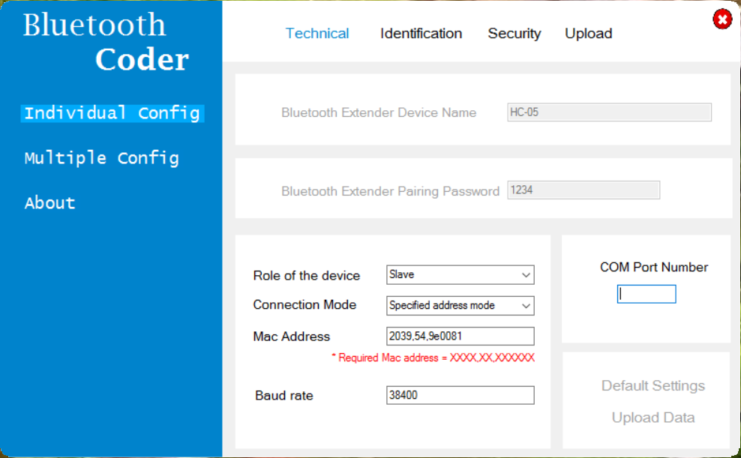

**Lite CD Ver 1.00**

**Bluetooth Extender device system**

**data update utility.**

**( Graphical platform for AT command mode of Bluetooth Extender )**

**This disk supports**

**Windows®8/8.1/10 64-bit only.**

**15091-33580000**







**Copyright©2020 S3 Engineering Lanka (Pvt). Ltd. All rights reserved. Copyright©2020 S3 Engineering Lanka (Pvt). Ltd.Tous droits reserves.**



**Lite CD Ver 1.00**

**DiHAC System data configuration.**

**SIM data configuration.**

**Bluetooth data configuration.**

**Security data configuration.**

**This disk supports**

**Windows®8/8.1/10 64-bit only.**

**15872-00582233**

Digital Home Automation Controller

DiHAC